

*VPCOE*

*A Report on*

**PROPELLER LED DISPLAY**

*Submitted by*

**CHINCHOLKAR APOORV R.**

**JOSHI SANKET S.**

**GORE RIGVED B.**

**Third Year Engineering**

**(Electronics & Telecommunication Engineering)**

*Guided by*

**MR.R.K.SHASTRI**

**Department of Elect & Tele.Engg.**

# CERTIFICATE

This is to certify that

1. Mr. Chincholkar Apoorv Ravindra

2. Mr. Joshi Sanket Satish

3. Mr. Gore Rigved Bhalchandra

The project **“PROPELLER DISPLAY”** is a bonafide work completed under my supervision and guidance in partial fulfillment for award of Bachelor of Engineering (Electronics & Telecommunication) Degree of Pune University.

Place : Baramati

Date :

**Mr.R.K.Shastri Mr.S.R.Deshpande**

**Guide Head of the Department**

**Principal**

**Vidyaprathishthan’s College of Engineering,**

**Baramati.**

**Acknowledgement**

First, we would like to express our best regards to our project guide **Mr.R.K.Shastri**, whose valuable guidance, encouragement, and provision of necessary facilities made this work possible.

We are also thankful to our respected Head of the Department **Mr.S.R.Deshpande** whose help and shared knowledge was the main support to complete our project. Many thanks are owed to our classmates for their useful discussion and timely suggestions. Their technical support and encouragement helped us to finalize our project.

Our special thanks to **Mr.Bapat** who helped us a lot through the problems we came across. We are absolutely grateful to all non-teaching staff for their assistance which is key factor behind our success. We would also like to express our gratitude towards the college for providing us with the best facilities and proper environment to work on our project.

Finally we offer our great thanks and regards to our family for their support which helped us through the difficulty and hardships of life to earn this achievement.

**Contents**

1. **Abstract 5**
2. **List of figures 6**

**Chapter 1. Introduction 7**

1.1 Literature survey 8

1.2 Block Diagram 9

1.3 Overview of Project 10

1.4 Overview of Block Diagram 11

**Chapter 2. Hardware Design 12**

2.1 Interrupter Module 13

2.2 Mechanical Assembly 15

2.3 Power Supply Module 18

**Chapter 3. Software Design 19**

3.1 Overview of software used 20

3.2 Algorithm 21

3.3 Flow Chart 22

3.4 Pseudo Code 23

**Chapter 4. PCB Design 25**

4.1 PCB designing steps 25

**Chapter 5.Results and Conclusion 26**

5.1 Interrupt module testing results 27

5.2 DC motor RPM measurement 28

5.3 Power Supply Testing 28

5.4 Displaying of generated patterns 29

**Chapter 6. Appendix 31**

6.1 User’s guide 32

6.2 Troubleshooting manual 33

6.3 References 34

6.4 Component cost list 35

6.5 Complete circuit Diagram 36

6.6 Datasheets 37

# (i) ABSTRACT

This project is a special kind of circular LED display. With the help some mechanical assembly, LED count, hardware requirement, and hence overall cost is cut to very affordable price. Also, maintenance and repairing of the display is so easy, that anyone having a little electronics knowledge, can take care of this. All the synchronizing can be implemented through software.

First of its kind, made using the 20-pin 8051 series microcontroller, this project use the principle of **Space Multiplexing.** This propeller display is mechanically scanned and displays the characters in digital format. Made from scrap it can be used anywhere and everywhere and the most amazing fact about this display is it’s crystal clear display. This display consists of just 8 bright LEDs which are rotated to show the display.

For building this project, requirement is just a small 20 pin microcontroller, a position encoder, and LEDs. This display can show the messages, which will require a whopping 525 LEDs. So hardware and cost minimization is achieved.

**(ii) LIST OF FIGURES**

|  |  |  |
| --- | --- | --- |
| **Figure no.** | **Name of Figure** | **Page no.** |
| 1. | BLOCK DIAGRAM | 9 |
| 2. | INTERRUPTER MODULE | 14 |
| 3. | OPERATION OF INTERRUPTER | 15 |
| 4. | MECHANICAL ASSEMBLY | 16 |
| 5. | POWER SUPPLY | 18 |
| 6. | FLOW CHART | 22 |
| 7. | INTERRUPTER MODULE TESTING | 27 |
| 8. | VARIOUS DISPLAY PATTERNS | 29 |

**Chapter 1**

**INTRODUCTION**

# C:\Program Files\Microsoft Office\MEDIA\CAGCAT10\j0297707.wmf

1.1 Literature survey

1.2 Block Diagram

1.3 Overview of Project

# 1.1 LITERATURE SURVEY

This project was started with a simple principle which is frequently encountered in our everyday life, which is Persistence of Vision. This phenomenon makes one feel fast moving/changing objects to appear continuous. A television is a common example, in which image is re-scanned every 25 times, thereby appear continuous.

Further, a glowing object if rotated in a circle at fast speed, it shows a continuous circle. By modifying this basic idea, 8 LEDs can be rotated in a circle, showing 8 concentric circles. But if these LEDs are switched at precise intervals, a steady display pattern can be shown.

**Existing Systems:**

Existing systems do employ POV principle, but for displaying each pixel, individual LED is used. This results in a huge number of LEDs even for small sized displays. By using a propeller type display, LED count can be kept to a bare minimum. Even 8 LEDs can perform a task of over 525 LEDs.

**Applications:**

Applications can find their way into cost effective solutions for large public displays, information systems. It can directly replace Railway station information displays, bus stands and many more places.

# 1.2 BLOCK DIAGRAM

**Fig.1 : block diagram of Propeller LED display**

# 1.3 OVERVIEW OF PROJECT

**What is PROPELLER LED DISPLAY???**

**PROPELLER:**

Propeller is a term associated with a circular rotating object. As this project needs to rotate whole circuit assembly, there must be some prime mover attached to it. So, the term ‘Propeller’.

**LED DISPLAY:**

This project using bright light emitting diodes for displaying the characters and symbols on its assembly.

That’s why this project is named as ‘PROPELLER LED DISPLAY’

**Basic principle behind this project:**

**POV (Persistance Of Vision):**

This is the phenomenon which is related to vision capability of human eye by which an after- image is thought to persist for approximately 1/25th of a second.

So, if someone is observing the images at a rate of 25 images per second, then they appear to be continuous. The best example of this property is the red circle we observe when we rotate the firecracker or incense stick in circle.

# 1.4 OVERVIEW OF BLOCK DIAGRAM

In this section we will emphasize on detailed overview of each of the block shown in previous block diagram. In every description of the block respective schematics and working is explained.

The propeller display consists of following blocks, as shown in the block diagram.

1. Interrupter Module
2. Microcontroller
3. LED module
4. DC motor
5. DC power supply
6. **Interrupter Module**

Interrupter module is our sensor module, consisting of the IR interrupt sensor MOC7811, from Motorola Inc. This sensor was selected from a variety of other alternatives, because of its small size, precise interrupt sensing, and sturdy casing.

One great advantage of using this module is, interfacing it with the microcontroller is just a matter of two resistors and a general purpose transistor. Following is the complete circuit diagram of our interrupter module.

**2.Microcontroller AT89C2051**

This project is based around the microcontroller AT89C2051, which is a derivative of 8051 family, from Atmel Inc. This is a 20 pin IC packaged in DIP package. This small sized IC is used, mainly because of its reduced weight. This improves the performance of the display, because reduced weight gives advantage of increased RPM.

**3.LED MODULE**

LED module consisting of 8 bright LED is fixed in another side of the arm of our project. These LEDs are connected with each of the port pin of microcontroller, with a series current limiting resistor of 470 ohm.

**4.DC Motor**

Repeated scanning of the display is must for continuous vision. This task is achieved using circular rotation of the whole circuit assembly. So, we used a DC motor as the prime mover.

**5.DC Power Supply**

For microcontroller, as well as the DC motor, a regulated DC power supply is required. We have to provide +5V to the microcontroller, while +12V to the motor.

**Chapter 2**

**Hardware Design**

**C:\Program Files\Microsoft Office\MEDIA\CAGCAT10\j0199727.wmf**

2.1 Overview of Block Diagram

2.2 Interrupter Module

2.3 Mechanical Assembly

2.4 Power Supply Module

**2.1 INTERRUPTER MODULE**

MOC7811 is the sensing part of the interrupter module, while rest of the circuitry works as signal conditioning ckt. 3 wires emerge out from the module, respectively Vcc, Signal and Ground. Output of the module is LOW, if interrupt occurs, otherwise it remains HIGH.

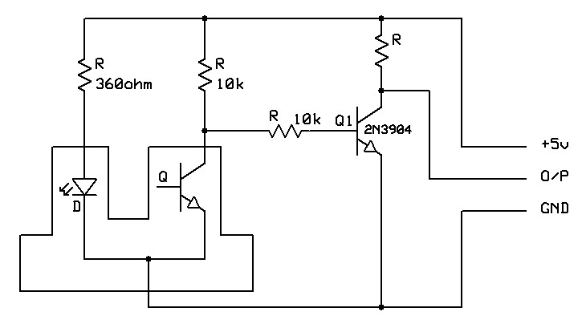

It consists of IR LED and Photodiode mounted facing each other enclosed in plastic body. When light emitted by the IR LED is blocked because of some completely opaque object, logic level of the photo diode changes. This change in the logic level can be sensed by the microcontroller or by discrete hardware. This sensor is used to give position feedback.

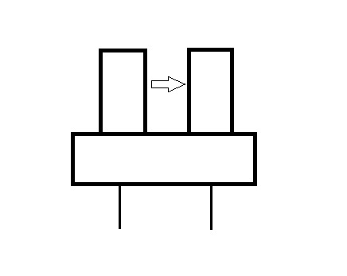 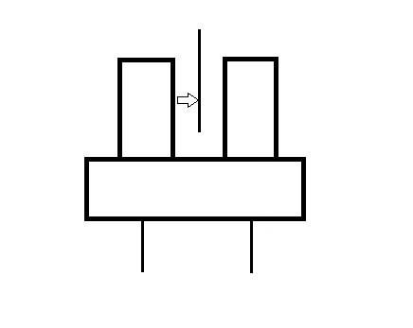

Output

**Signal Conditioning :**

INT0 pin of our microcontroller is Active Low. That means, occurrence of each interrupt is should be signaled with Low logic level. So, we must invert the output of the sensor.

**Transistor 2N3904:**

This a general purpose silicon NPN transistor. It is connected in the CE inverting amplifier configuration. It inverts the output of the photodiode, and also improves the transient response.

# 2.2 MECHANICAL ASSEMBLY

Mechanical assembly plays a vital role in proper functioning of this project. The display is scanned each time, by rotating the whole assembly in a circular path. The basic idea we developed is on our own, by implementing and modifying different ways to do this.

Following diagram shows the most reliable way, that we finally selected.

Here, one major challenge was how to bring +5V supply to the spinning circuit. We tried the same by adopting two-three different methods, but finally concluded on the method, as shown in the figure.

As seen in the diagram, one supply connection (GND) is provided

through the motor’s shaft. Other terminal (Vcc) is connected, by arranging a friction disc-brush arrangement. The brush keeps its contact with the disc, so that current can be supplied.

Most critical objective was to achieve pristine balance and overall good mechanical strength. For weight adjustment, we have provided one long screw, and weight can be attached or removed by adding / removing metallic bolts. If the assembly is balanced perfect, then it can achieve stability, and rotate at high RPMs too. This will improve the overall efficiency of this display.

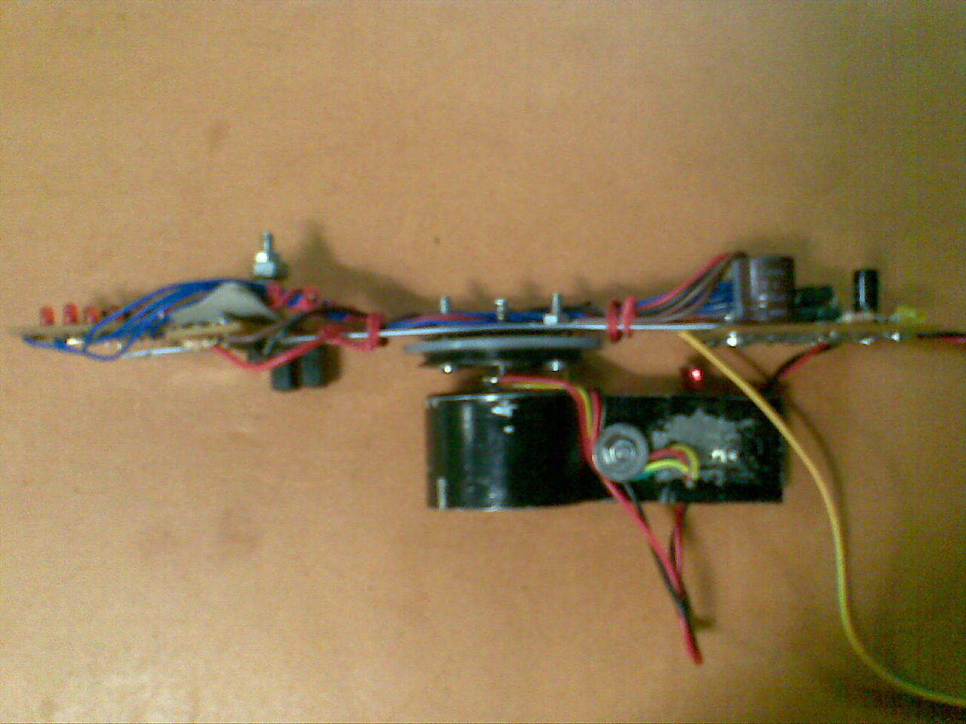

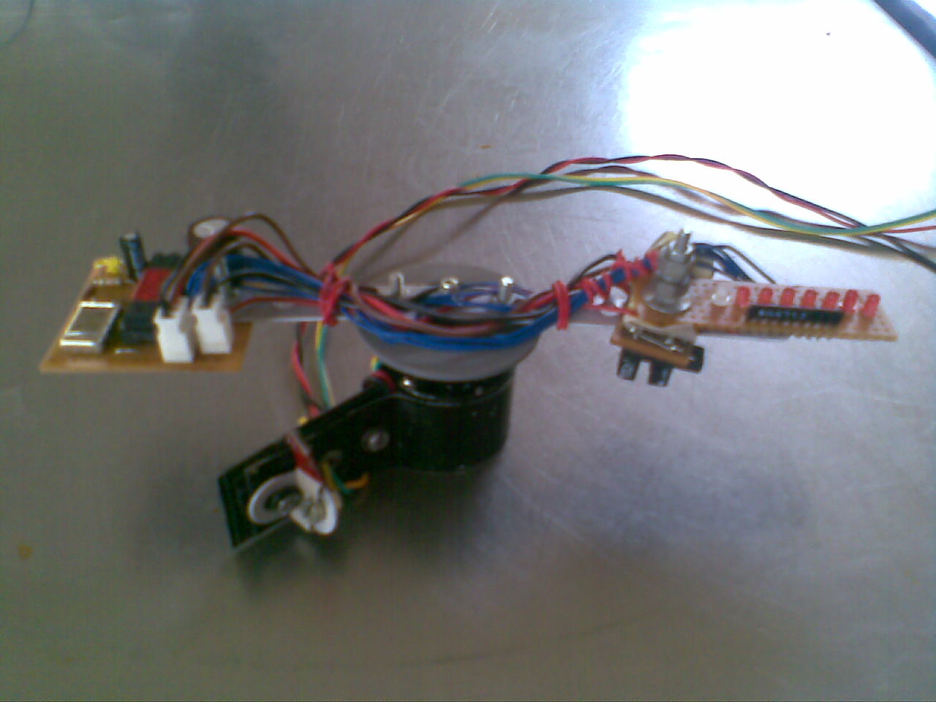

# 2.3 POWER SUPPLY

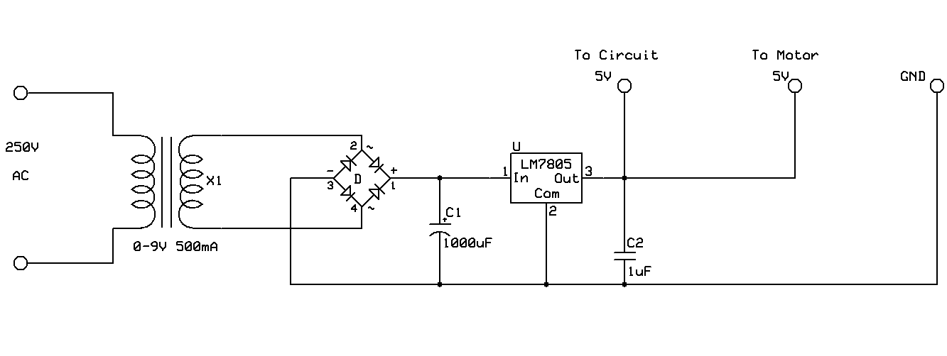

A fixed voltage power supply producing constant +5V consists of step down transformer, a bridge rectifier, filter capacitors C1 and 3 terminal regulator IC LM7805. A step down transformer is selected in such a way that it produces 9V at the input of IC. This power supply is capable of supplying +5v and load current up to 500m A.

The capacitor C2 connected between output terminal and ground cancels out any inductive effect due to long distribution leads. Input capacitor C1 is used to improve transient response of the regulator IC, i.e. response of regulator to sudden changes in load. It is also helpful in reducing the noise present in the output. Dropout voltage (Vin-Vout) needs to be at least 2V under all operating conditions for proper operation of regulator.

# Chapter 3

# Software Design

C:\Program Files\Microsoft Office\MEDIA\CAGCAT10\j0292982.wmf

3.1 Overview of software used

3.2 Algorithm

3.3 Flow Chart

3.4 Pseudo Code

# 3.1 SOFTWARE USED

# Ride IDE

The Raisonance 8051 Development Kits are a complete solution for creating software for the 8051 family of microcontrollers. The Development Kits comprise many different tools that allow projects ranging from simple to highly complex to be developed with relative ease. You will find that with the Raisonance Development Kits you can rely on tools that have been tested by real users over a long period of time.

Ride provides a familiarity to the tools that will provided a basis for using more complex features. It is assumed that the user is familiar with Windows and has at least some familiarity with the 8051 microcontroller family and the C programming language

# 3.2 ALGORITHM

**Main routine:**

1. Load proper value in IE register, so that the interrupts INT0 and T0 are enabled. (IE = 83H)
2. Offer higher priority to the INT0 (External) interrupt. (IP = 01H)
3. Configure timer 1 as 16-bit timer, and timer 0 as 8-bit auto reload mode timer. ( TMOD = 12H)
4. INT0 should be configured as edge interrupt. (IT0 = 1)
5. Configure port 3 as input port. (P3 = 0FFH)
6. Move input string to the video RAM area. (call ‘ramc’ function)
7. Start the timers.
8. Initiate an infinite loop.

**Interrupt Routines:**

1. **External Interrupt:**
2. Stop the timers.
3. Move th1 and tl1 into convenient registers.
4. Divide this 16 bit value by our total number of segments.
5. Subtract the answer from 256, and load the result in th0.
6. Now, reset the video RAM pointer and character segment pointers to their initial respective positions.
7. Start the timers.
8. Return from interrupt.
9. **Timer 0 Interrupt:**
10. Call the display routine.
11. Clear timer overflow flag.
12. Return from interrupt.

# 3.3 FLOW CHART

T0

INT0

Power ON

Infinite Loop

**Timer 0 Interrupt**

Display next segment

**External Interrupt**

- Stop the timers

- Reset Video RAM pointer

- Reset segment Pointer

- Divide 16 bit value TH1:TL1

- Load answer in TH0

- Start both timers

Move appropriate values to specific SFRs

# 3.4 PSEUDO CODES

1. **Code for the timer 0 interrupt:**

interr: ;T0 interrupt

cjne r6,#0ffh,sk

mov r6,#00h

acall disp

sjmp sk1

sk:

mov r6,#0ffh

sk1:

clr tf0

ret

This interrupt is intended for displaying each segment at regular time interval. The interrupt gets executed after each timer 0 overflow, which overflows at adjustable time intervals.

1. **Code for the External Interrupt:**

; EXT0 interruupt

interr1:

clr tr1

clr tr0

mov a,th1

mov r1,a

mov a,tl1

mov r0,a

mov r3,#00h

mov r2,#160

acall div16_16

mov a,r2

subb a,0ffh

mov th0,a

mov tl0,a

mov th1,#00h

mov tl1,#00h

setb tr1

setb tr0

mov r0,#23h

mov r5,#00h

mov r6,#00h

ret

This interrupt performs the basic task of synchronization. It also resets the character pointer (R0), the segment pointer (R5). Another thing performed in this interrupt is that, the previous time gets divided into number of segments, and the concluding result will be stored in the timer register TH1.

# Chapter 4

**PCB DESIGN**

# 4.1 PCB DESIGNING STEPS

The most important requirement of this project was to build a PCB with minimum weight and size. A Zero PCB is a drilled board. Drilling process removes a lot of material from board, and the weight is reduced. Designing method is as follows.

1. Decide proper places for components
2. Actual Placement of components on Zero PCB
3. Connecting Tracks with solid wires
4. Testing for continuity and Debugging

Four PCBs are designed in this project. The main PCB, the LED module, and power supply PCB. All PCBs are constructed on simple zero PCB, and interconnection of components was done by single stranded wires.

# Chapter 5

# Results and Conclusions

C:\Program Files\Microsoft Office\MEDIA\CAGCAT10\j0299171.wmf

5.1 Interrupt module testing results

5.2 DC motor RPM measurement

5.3 Power Supply testing

5.4 Display of generated patterns

This project includes testing of three modules as stated below

1.Interrupter module testing

2.DC Motor RPM testing

3.Power supply module testing

# 5.1 INTERRUPTER MODULE TESTING

This Interrupter module testing is required for detecting exact position of wheel on which whole circuit assembly is mounted.

Supply voltage given to Pin. No. 1(Collector) and Pin.No.3(Anode) of MOC7811=5.5V

Output voltage obtained at Pin.No.1 of MOC 7811 without interrupt=5.21v

Output voltage obtained at Pin.No.1 of MOC7811 with interrupt=0.08V

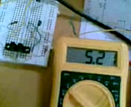 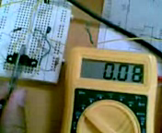

# 5.2 DC MOTOR RPM TESTING

DC Motor used in this project is 12 V dc motor which is tested by using digital contact-less tachometer. Arrangement was made so that the sensing circuit gives high to low pulse for each completion of revolution. By measuring the time difference between two successive pulses RPS can be calculated which further provide RPM value, as shown below:

Power supply given to DC Motor = 9V

Time interval between two successive pulses as seen on CRO = 30.4ms

RPS = 1 / (30.4ms)

=32.89

RPS = 33

RPM= 33x60

RPM = 1975

# 5.3 POWER SUPPLY MODULE TESTING

# Power supply module was designed to provide 5V DC power supply necessary to drive both motor and circuit. AC input is given from 9V 750mA transformer. Results are as follows.

Input voltage, Vs=9V AC

Output voltage observed , Vo = 4.92V DC

# 5.4 DISPLAY OF GENERATED PATTERNS

# Image370.jpg Image373.jpg

# Displaying a Quarter circle Displaying a Half Circle

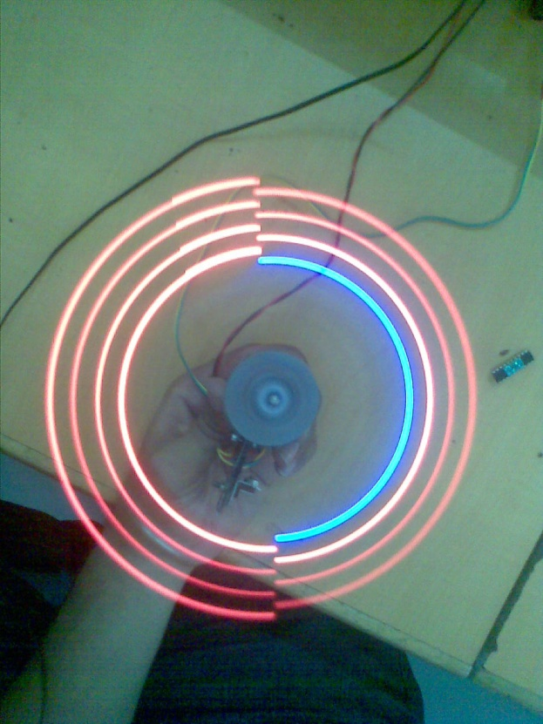 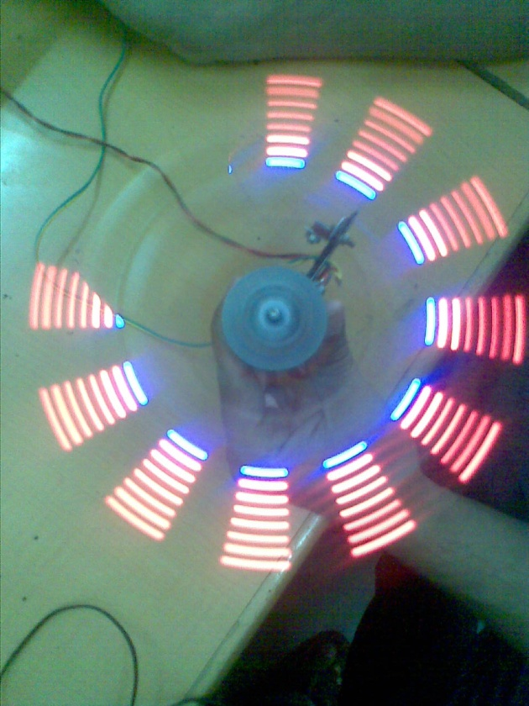

# Displaying an alternate pattern circle Displaying an feather like pattern

# 

# Image378.jpg Image377.jpg

# Displaying a pattern Displaying a dual quarter Circle

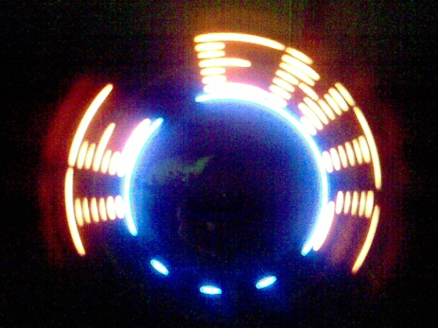

Displaying a character string

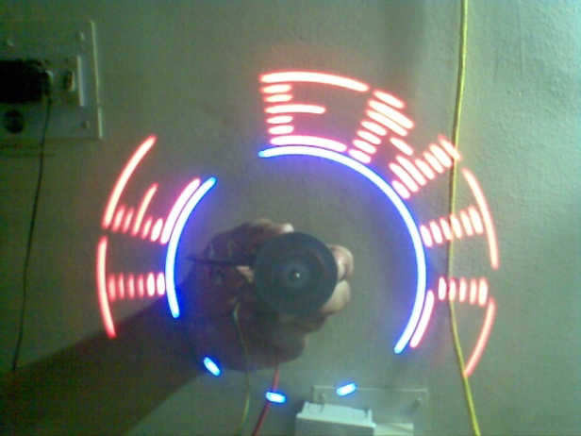 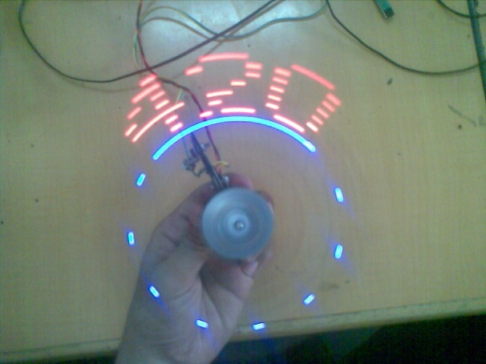

Displaying a character string Displaying a number string

# Chapter 6

# Appendix

# C:\Program Files\Microsoft Office\MEDIA\CAGCAT10\j0090070.wmf

6.1 User’s guide

6.2 Troubleshooting manual

6.3 Datasheets

6.4 References

6.5 Complete circuit Diagram

6.6 Component cost list

# 6.1 USER’S GUIDE

STEPS TO BE PERFORMED BEFORE STARTUP:-

1. Connect the power cord to the AC mains power supply of 230V.
2. Check whether the output of IC LM7805 is 5V or not. The power supply is ok if the output is 5V.
3. Now, connect the voltmeter’s probes to the motor’s terminals. 5V is the desired voltage there.
4. See if the YELLOW LED on the main PCB is glowing or not. Glowing LED indicates that it is receiving proper input voltage and so, on the Vcc of the microcontroller.
5. Adjust the interrupt ( Red strip) so that it easily passes through the sensor.
6. Check if the Pin 6 of the microcontroller receives LOW voltage when interrupt occurs, and HIGH voltage, otherwise.
7. Finally, ensure that the standing assembly does not have any discrepancies.

# 6.2 TROUBLESHOOTING MANUAL

1. Output voltage of LM7805 is not 5V

* Test the continuity throughout the wires, as shown in the circuit diagram.
* Replace appropriate component, if needed.

1. DC motor is not rotating

* Check the current flowing through the motor. If it reaches above 750mA, then the motor is short, Replace it.
* In case of jamming, try to grease the bearing and shaft.

1. The display rotates, but not displaying garbage values.

* Check the red strip (Interrupt) is in proper position or not. If not, adjust it.

1. Some or all LEDs not glowing.

* Check the relimate connector, that connects the LED module to the microcontroller.
* Otherwise, check the continuity through each wire.
* If the connections are ok, then replace the particular LED.

1. For any other problems or queries than these, please contact below.

* [apoorvc2005@gmail.com](mailto:apoorvc2005@gmail.com)
* [sanket9290@gmail.com](mailto:sanket9290@gmail.com)
* [grigved@gmail.com](mailto:grigved@gmail.com)

# 6.3 REFERENCES:-

1. [**www.nex-robotics.com**](http://www.nex-robotics.com)
2. [**www.logicbrigade.com**](http://www.logicbrigade.com)
3. **www.8052projects.com**
4. **“The 8051 microcontroller and Embedded Systems” by M.A.Mazidi**

# 6.4 COMPONENT PRICE LIST

|  |  |  |  |
| --- | --- | --- | --- |
| **Sr. No** | **Part** | **Qty.** | **Cost** |
| 1 | AT89C2051 | 2 | 76/- |
| 2 | MOC7811 | 1 | 32/- |
| 3 | Tape Recorder Flywheel | 1 | 30/- |
| 4 | 12V DC Motor | 1 | 30/- |
| 5 | LM7805 | 1 | 08/- |
| 6 | 1A bridge | 1 | 08/- |
| 7 | Resistors: |  |  |
|  | 10K | 3 | 06/- |
|  | 1K | 1 | 01/- |
|  | 360ohm | 1 | 01/- |
|  | 470ohm network | 1 | 05/- |
| 8 | Capacitors: |  |  |
|  | 10uF,16V | 1 | 01/- |
|  | 33pF | 2 | 02/- |
|  | 1000uF,25V | 1 | 04/- |
| 9 | Relimate connector (3pin) | 1 | 07/- |
| 10 | Relimate connector (2pin) | 1 | 05/- |
| 11 | Zero PCB | 2 | 10/- |
| 12 | Soldering Wire | 3m | 15/- |
| 13 | Desoldering Wire | 1m | 15/- |
|  |  |  |  |
|  |  | Total: | 256/- |